Tommy University course

**Graduate work**

***“*** ***Testing the site https://hillary-shop.com.ua ”***

11 group

Specialty *“QA/QC tester”*

###### Olesya Pavlyuk

Chernivtsi 2021**CONTENT**

1. **Сheck-list for 25 items, covering only ONE page of the site https://hillary-shop.com.ua 3**
2. **15 test cases using test design techniques and different TYPES of testing 6**
3. **Automation testing in Selenium IDE 20**

**4. Write 10 user stories to the functionality of the site, turn them into requirements 26**

**5. Write 10 user stories to the external interface of the site, turn into requirements 27**

**6. All defects which were found on the site write in the bug reports, set the type, priority, severity 28**

**7. Create a database that could match the site (users, products for the online store, etc.). An average of 3 tables (at least 10 units in the table). Create the necessary links in the table, fill the tables with data. 34**

## **Сheck-list for 25 items, covering only ONE page of the site https://hillary-shop.com.ua**

|  |  |  |  |
| --- | --- | --- | --- |
| № | Name | Status | Comment |
| 1 | Enter the numbers in the name bar while registering in the personal account | Pass | 123454567 |
| 2 | Enter invalid email while registering in the personal account | Fail | dsfghjkl@gmail.com |
| 3 | Enter valid email while registering in the personal account | Pass | leskapavlyuk@gmail.com |
| 4 | Registering the personal account with unreliable password | Fail | 12345 |
| 5 | Registration with empty, required fields | Pass |  |
| 6 | Register via Facebook, enter an invalid email and password | Pass | sdfghjkl@gmail.com, пароль 23456789 |
| 7 | Login to the personal account through a valid Google account | Pass | leskapavlyuk@gmail.com |
| 8 | Registration with previously registered email | Pass | Email: dsfghjkl@gmail.com |
| 9 | Login to the personal account with a valid email and an invalid password | Pass | [leskapavlyuk@gmail.com](mailto:leskapavlyuk@gmail.com), password 12345 |
| 10 | Open the site from a laptop, increase and decrease the size on the home page | Pass |  |
| 11 | Open the site from a laptop, make an order «Чай из черной гречки Hillary Tartary buckwheat tea» | Pass |  |
| 12 | Open the site from the tablet, increase and decrease the size on the main page | Pass |  |
| 13 | Open the site from the tablet, make an order «Чай из черной гречки Hillary Tartary buckwheat tea» | Pass |  |
| 14 | Open the site from your phone, increase and decrease the size on the main page | Pass |  |
| 15 | Open the site from the tablet, make an order «Чай из черной гречки Hillary Tartary buckwheat tea» | Pass |  |
| 16 | Text placed under the request of the product | Pass |  |
| 17 | Placing the order of the goods next to each other, the same size | Pass |  |
| 18 | Placed advertising does not interfere with viewing the product | Pass |  |
| 19 | Go to the main page and switch the language from Ukrainian to Russian, are the words translated correctly? | Fail |  |
| 20 | Go to the main page, go to the product selection and visually check the grammar and spaces in the words | Fail | There are not similar punctuation marks |
| 21 | Go to the main page, go to the product selection and visually check the presence of extra characters in words | Pass | In the discription of product Набір для ідеальної шкіри тіла в домашніх умовах "Nice body Plus" there is no parenthese |
| 22 | The company favicon is located in a prominent place. | Fail | It’s too small and not prominent |
| 23 | Search for a product by a valid name | Pass |  |
| 24 | Entering invalid data in the product search | Pass |  |
| 25 | The site has a favicon in the style of the company logo. | Pass |  |

## **15 test cases using** **test design techniques and different TYPES of testing**

1. **Research testing**

| С1: Check the graphical display of the site on different devices: phone, tablet, computer | | | |
| --- | --- | --- | --- |
| TypeFunctional UI testing | PriorityHigh | Estimate 15 minutes | ReferencesNone |
| Automation TypeNone | Opened site in the browser <https://hillary-shop.com.ua/>  Working devices: a phone, a tablet, a computer or laptop. | | |
| **Preconditions** |
|  |
| **Steps** |  |  |  |
|  | Step | Expected Result | |
| 1 | Go to the site from your phone | There are no graphic changes, all image sizes are reduced to the size of the phone screen | |
| 2 | Go to the site from the tablet | There are no graphic changes, all image sizes are reduced to the size of the tablet | |
| 3 | Go to the site from your computer | There are no graphic changes | |

1. **Research testing**

| С2: Graphical display check (according to graphic display standards) | | | |
| --- | --- | --- | --- |
| TypeFunctional  UI testing | PriorityHigh | Estimate 15 minutes | ReferencesNone |
| Automation TypeNone | Opened site in the browser https://hillary-shop.com.ua/ | | |
| **Preconditions** |
|  |
| **Steps** |  |  |  |
|  | Step | Expected Result | |
| 1 | Go to the site and check the placement of the text | The text is placed below the image of the product, the size of the text decreases with the size of the image | |
| 2 | Go to the site and check the placement of images | Pictures of the product are placed in the same order, one after another, images of the same size | |
| 3 | Go to the site and check the placement of advertising | Advertising is placed in a place where it will be clearly visible, does not cover the product | |

1. **Research testing**

| С3: Сhange of language | | | |
| --- | --- | --- | --- |
| Type Localization | PriorityMedium | Estimate 5 minutes | ReferencesNone |
| Automation TypeNone | Opened site in the browser <https://hillary-shop.com.ua/> | | |
| **Preconditions** |
| **Steps** |  |  |  |
|  | Step | Expected Result | |
| 1 | Change the language of the site to Ukrainian | All words and buttons in Ukrainian | |
| 2 | Change the language of the site to Russian | All words and buttons in Russian | |

**4. Research testing**

| С4: Checking the compatibility of the site with different browsers | | | |
| --- | --- | --- | --- |
| TypeConfiguration | PriorityMedium | Estimate 20 minutes | ReferencesNone |
| Automation TypeNone | Open site <https://hillary-shop.com.ua/> in browsers: Google Chrome, Opera, Yandex browser, Mozilla Firefox | | |
| **Preconditions** |
|  |
| **Steps** |  |  |  |
|  | Step | Expected Result | |
| 1 | Go to the main page of the site from the Google Chrome browser | The site works, the order can be placed | |
| 2 | Go to the main page of the site from the Opera browser | The site works, the order can be placed | |
| 3 | Go to the main page of the site from the Yandex browser | The site works, the order can be placed | |
| 4 | Go to the main page of the site from the Mozilla Firefox browser | The site works, the order can be placed | |
| 5 | Go to the main page of the site from the Google Chrome browser | The site works, the order can be placed | |

**5. Guessing mistakes**

| С5: Creating an account | | | |
| --- | --- | --- | --- |
| TypeFunctional | PriorityHigh | Estimate 15 minutes | ReferencesNone |
| Automation TypeNone | Opened site in the browser <https://hillary-shop.com.ua/>  Existing name and e-mail to enter the personal account | | |
| **Preconditions** |
|  |
| **Steps** |  |  |  |
|  | Step | Expected Result | |
| 1 | Create an account without filling in the required name field | Account not created | |
| 2 | Enter the name of the number in the field | Account not created | |
| 3 | Enter 2 different names on one Email | Account not created | |
| 4 | Enter a non-existent Email in the Email field: dfm@gmail.com | Account not created | |
| 5 | Enter a valid Email in the Email field | Account created | |

**For this test-case we can use test design technique decision-making table**

|  |  |  |  |  |  |  |  |  |  |
| --- | --- | --- | --- | --- | --- | --- | --- | --- | --- |
| Logging on to the site in the personal account | | | | | | | | | |
| **Coditions** | **1** | **2** | **3** | **4** | **5** | **6** | **7** | **8** |
| Valid name | 1 | 1 | 1 | 1 | 0 | 0 | 0 | 0 |
| Valid password | 1 | 0 | 1 | 0 | 0 | 1 | 0 | 1 |
| Valid phone number | 1 | 0 | 0 | 1 | 0 | 1 | 1 | 0 |
| Not valid name | 0 | 0 | 0 | 0 | 1 | 1 | 1 | 1 |
| Not valid password | 0 | 1 | 0 | 1 | 1 | 0 | 1 | 0 |
| Not valid phone number | 0 | 0 | 1 | 0 | 1 | 0 | 0 | 1 |
| **Action** |  |  |  |  |  |  |  |  |
| Successfully registration | 1 | 0 | 0 | 0 | 0 | 0 | 0 | 0 |
| Unsuccessfully registration | 0 | 1 | 1 | 1 | 1 | 1 | 1 | 1 |

**For this test-case we can use test design technique**

**state-transition diagram**



**6. Guessing mistakes**

| С6: Functional " Add products to the basket " | | | |
| --- | --- | --- | --- |
| TypeFunctional | PriorityMedium | Estimate 10 minutes | ReferencesNone |
| Automation TypeNone | Opened site in the browser <https://hillary-shop.com.ua/>  Existing name and e-mail to enter the personal account | | |
| **Preconditions** |
|  |
| **Steps** |  |  |  |
|  | Step | Expected Result | |
| 1 | Select the product “[Чай з чорної гречки Hillary Tartary buckwheat tea](https://hillary-shop.com.ua/chay-iz-chernoy-grechki-hillary-tartary-buckwheat-tea/)” and add to the shopping basket by clicking the "Купити" button | Product is in the basket | |
| 2 | Remove the item from the basket | The product deleted from the basket | |

**7. Guessing mistakes**

| С7: Functional «Filters», using of two filters at the same time | | | | |
| --- | --- | --- | --- | --- |
| Type Load testing | PriorityMedium | Estimate 10 minutes | ReferencesNone |
| Automation TypeNone | Opened site in the browser <https://hillary-shop.com.ua/> | | | |
| **Preconditions** |
|  |
| **Steps** |  |  |  |
|  | Step | Expected Result | |
| 1 | Select " Cироватки для волосся " filter | Display of goods intended for hair | |
| 2 | Select "Для росту волосся" filter | Display of goods intended for hair growth | |

**8. Guessing mistakes**

| С8: Functional «Find» | | | |
| --- | --- | --- | --- |
| TypeFunctional | PriorityMedium | Estimate 10 minutes | ReferencesNone |
| Automation TypeNone | Opened site in the browser <https://hillary-shop.com.ua/> | | |
| **Preconditions** |
|  |
| **Steps** |  |  |  |
|  | Step | Expected Result | |
| 1 | Enter in the field to find a non-existent product «Мочалка» | No product displayed | |
| 2 | Enter in the field to enter the existing valid product «Масажна щітка для сухого масажу» | Display of the found products | |

**9. Guessing mistakes**

| С9: Functional " Sorting " | | | |
| --- | --- | --- | --- |
| TypeFunctional | PriorityMedium | Estimate 20 minutes | ReferencesNone |
| Automation TypeNone | Opened site in the browser <https://hillary-shop.com.ua/> | | |
| **Preconditions** |
|  |
| **Steps** |  |  |  |
|  | Step | Expected Result | |
| 1 | Сhoose products for the face | Display of goods intended for face | |
| 2 | Click sort by "popular" | Sorting goods by criterion is popular by the number of orders for this product | |
| 3 | Click sort from expensive to cheap | Sorting goods by price from expensive goods to cheap ones | |
| 4 | Click to sort by cheap to expensive | Sorting goods by price from cheap to expensive | |

**10. Guessing mistakes**

| С10: Customer support | | | |
| --- | --- | --- | --- |
| Type Usability | PriorityMedium | Estimate 20 minutes | ReferencesNone |
| Automation TypeNone | Opened site in the browser <https://hillary-shop.com.ua/>  Existing name and e-mail to enter the personal account | | |
| **Preconditions** |
|  |
| **Steps** |  |  |  |
|  | Step | Expected Result | |
| 1 | Call the hotline  0 800 750 149 | The call is answered | |
| 2 | Write to email info@hillary-shop.com.ua | The letter receives a reply | |
| 3 | Write to Viber [063 700 09 95](https://api.whatsapp.com/send?phone=0637000995) | The message is answered | |
| 4 | Write to Telegram [hillarycomua](tg://resolve?domain=hillarycomua) | The message is answered | |

**11. Research testing**

| С11: Using all filters and sortings | | | |
| --- | --- | --- | --- |
| TypePerformance | PriorityHigh | Estimate 20 minutes | ReferencesNone |
| Automation TypeNone | Opened site in the browser <https://hillary-shop.com.ua/> | | |
| **Preconditions** |
|  |
| **Steps** |  |  |  |
|  | Step | Expected Result | |
| 1 | Click on category “Акції та подарунки” | Display of goods from category “Акції та подарунки” | |
| 2 | Select " Хіт" filter | Display of goods from category “Акції та подарунки”, " Хіт" | |
| 3 | Select " Очищення та тонізування " filter | Display of goods from category “Акції та подарунки”, " Хіт", " Очищення та тонізування " | |
| 4 | Select " Від чорних цяток " filter | Display of goods from category “Акції та подарунки”, " Хіт", " Очищення та тонізування ", " Від чорних цяток " | |
| 5 | Select " Ціна від 0 до 299 " filter | Display of goods from category “Акції та подарунки”, " Хіт", " Очищення та тонізування ", " Від чорних цяток ", " Ціна від 0 до 299 " | |
| 6 | Click sort by "popular" | Sorting goods by criterion is popular by the number of orders for this product | |
| 7 | Click sort from expensive to cheap | Sorting goods by price from expensive goods to cheap ones | |
| 8 | Click to sort by cheap to expensive | Sorting goods by price from cheap to expensive | |

**12. Research testing**

| С12: "Add products to the basket " | | | |
| --- | --- | --- | --- |
| TypeFunctional | PriorityHigh | Estimate 20 minutes | ReferencesNone |
| Automation TypeNone | Opened site in the browser <https://hillary-shop.com.ua/>  Existing name and e-mail to enter the personal account | | |
| **Preconditions** |
|  |
| **Steps** |  |  |  |
|  | Step | Expected Result | |
| 1 | Select the product “[Чай з чорної гречки Hillary Tartary buckwheat tea](https://hillary-shop.com.ua/chay-iz-chernoy-grechki-hillary-tartary-buckwheat-tea/)” and add to the shopping basket by clicking the "Купити" button | Product is in the basket | |
| 2 | Select quantity of the product 2147483640 | Product can be ordered only in an available quantity in stock | |
| 3 | Select quantity of the product 0 | Product can be ordered only in an available quantity in stock > 0 | |

**For this test-case we can use test design technique**

**equivalent separation**

|  |  |  |  |
| --- | --- | --- | --- |
|  | | Status | Comment |
| The good «Чай з чорної гречки Hillary Tartary buckwheat tea» can be ordered from 1 to 2147483647 pcs | | | |
| Valid value | order 1 pcs | Pass |  |
| Inalid value | order 2147483648 pcs | Fail |  |

**For this test-case we can use test design limit value**

|  |  |  |  |
| --- | --- | --- | --- |
|  | | Status | Comment |
| The good «Чай з чорної гречки Hillary Tartary buckwheat tea» can be ordered from 1 to 2147483647 pcs | | | |
| Valid value | order 1 pcs | Pass |  |
| Valid value | order 2147483647 pcs | Pass |  |
| Inalid value | order 0 pcs | Pass |  |
| Inalid value | order 2147483648 pcs | Fail |  |

**13. Research testing**

| С13: " Ordering products from the basket " | | | |
| --- | --- | --- | --- |
| TypeFunctional | PriorityHigh | Estimate 20 minutes | ReferencesNone |
| Automation TypeNone | Opened site in the browser <https://hillary-shop.com.ua/>  Existing name and e-mail to enter the personal account | | |
| **Preconditions** |
|  |
| **Steps** |  |  |  |
|  | Step | Expected Result | |
| 1 | Select the product “[Чай з чорної гречки Hillary Tartary buckwheat tea](https://hillary-shop.com.ua/chay-iz-chernoy-grechki-hillary-tartary-buckwheat-tea/)” and add to the shopping basket by clicking the "Купити" button | Product is in the basket | |
| 2 | Select quantity of the product 2147483647 | Product added to the basket in an available quantity in stock | |
| 3 | Click the button “Оформити замовлення” | The page “Оформлення замовлення” opens | |
| 4 | Click the button “Я новий покупець” | The tab “Я новий покупець” is opened | |
| 5 | Fill in the field “ПІБ” 56789щ0з-х | Error, the field can contain only letters | |
| 6 | Don’t fill in the field “Телефон” | Error, the field must be not null | |
| 7 | Fill in the field “Місто” swdfgh | Error, the field can contain only existing cities | |
| 8 | Don’t fill in the field “Е-пошта” | Error, the field must be not null | |
| 9 | Fill in the field “Доставка”, click “Доставка за адресою” | The field “Доставка” contain “Доставка за адресою” | |
| 10 | Don’t fill in the field “Адреса” | Error, the field must be not null | |
| 11 | Fill in the field “Оплата”, click “Оплата при отриманні” | The field “Оплата” contain “Оплата при отриманні” | |
| 12 | Fill in the field “Оплата”, click “Онлайн-оплата банківською картою (WayForPay)” | The field “Оплата” contain “Онлайн-оплата банківською картою (WayForPay)” | |
| 13 | Fill in the field “Оплата”, click “Виберу з менеджером” | The field “Оплата” contain “Виберу з менеджером” | |
| 14 | Click the button “Оформити замовлення” | The order is placed if all previously required fields are filled correctly | |

**For this test-case we can use test design decision-making table**

|  |  |  |  |  |
| --- | --- | --- | --- | --- |
| Making an order for goods | | | | |
| **Coditions** | **1** | **2** | **3** | **4** |
| Buy available product | 1 | 1 | 0 | 0 |
| Buy product in available quantity | 1 | 0 | 1 | 0 |
| Buy not available product | 0 | 0 | 1 | 1 |
| Buy product in not available quantity | 0 | 1 | 0 | 1 |
| **Action** |  |  |  |  |
| Successfully order | 1 | 0 | 0 | 0 |
| Unsuccessfully order | 0 | 1 | 1 | 1 |

**14. Research testing**

| С14: " Ordering product which is not available" | | | |
| --- | --- | --- | --- |
| TypeFunctional | PriorityHigh | Estimate 20 minutes | ReferencesNone |
| Automation TypeNone | Opened site in the browser <https://hillary-shop.com.ua/>  Existing name and e-mail to enter the personal account | | |
| **Preconditions** |
|  |
| **Steps** |  |  |  |
|  | Step | Expected Result | |
| 1 | Go to the last page of products menu “Акції та подарунки” | The last page displays products that are not available | |
| 2 | Select the product “Набір для сяючої шкіри SUNSHINE DUO ” and add to the shopping basket by clicking the "Купити" button | There is no button "Купити". There is only button "Повідомити коли з’явиться". | |

**15. Research testing**

| С15: Functional "Замовлення через кошик: 24/7/365 днів" | | | |
| --- | --- | --- | --- |
| TypeFunctional | PriorityHigh | Estimate 20 minutes | ReferencesNone |
| Automation TypeNone | Opened site in the browser <https://hillary-shop.com.ua/>  Existing name and e-mail to enter the personal account | | |
| **Preconditions** |
|  |
| **Steps** |  |  |  |
|  | Step | Expected Result | |
| 1 | Select the product “Чай з чорної гречки Hillary Tartary buckwheat tea” and add to the shopping basket by clicking the "Купити" button | Product is in the basket | |
| 2 | Select quantity of the product 5 | Product can be ordered only in an available quantity in stock | |
| 3 | Click the button “Оформити замовлення” at 22:05 on Sunday | The order must be placed in any time  24/7/365 days | |

**For all these test-cases we can use test design use-case diagram**

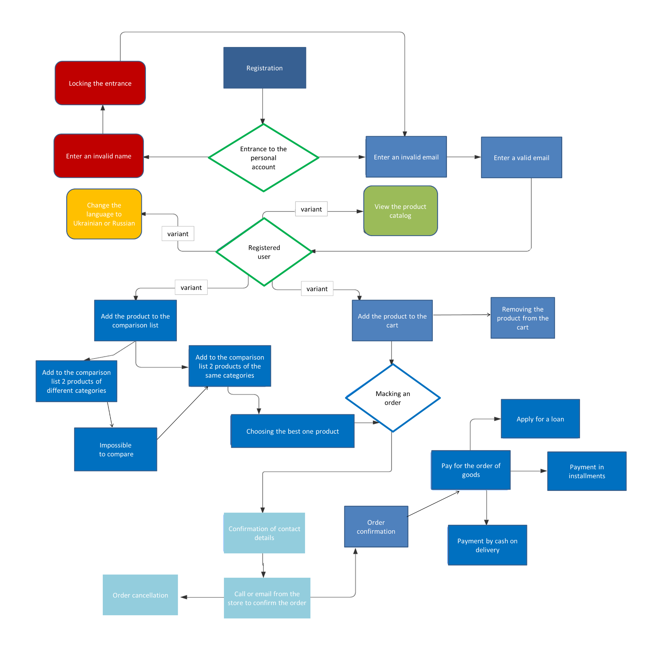

## **Automation testing in Selenium IDE**

1. С2: Graphical display check (according to graphic display standards)

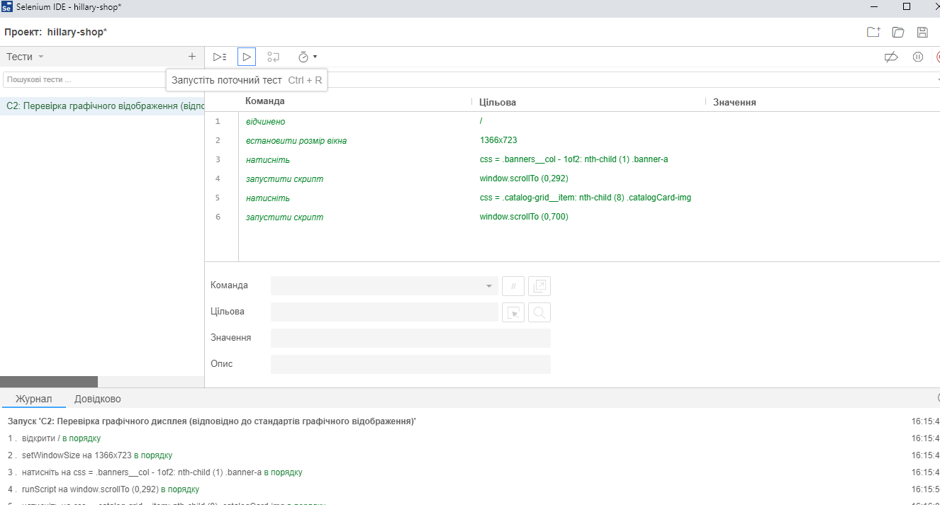

1. С3: Сhange of language

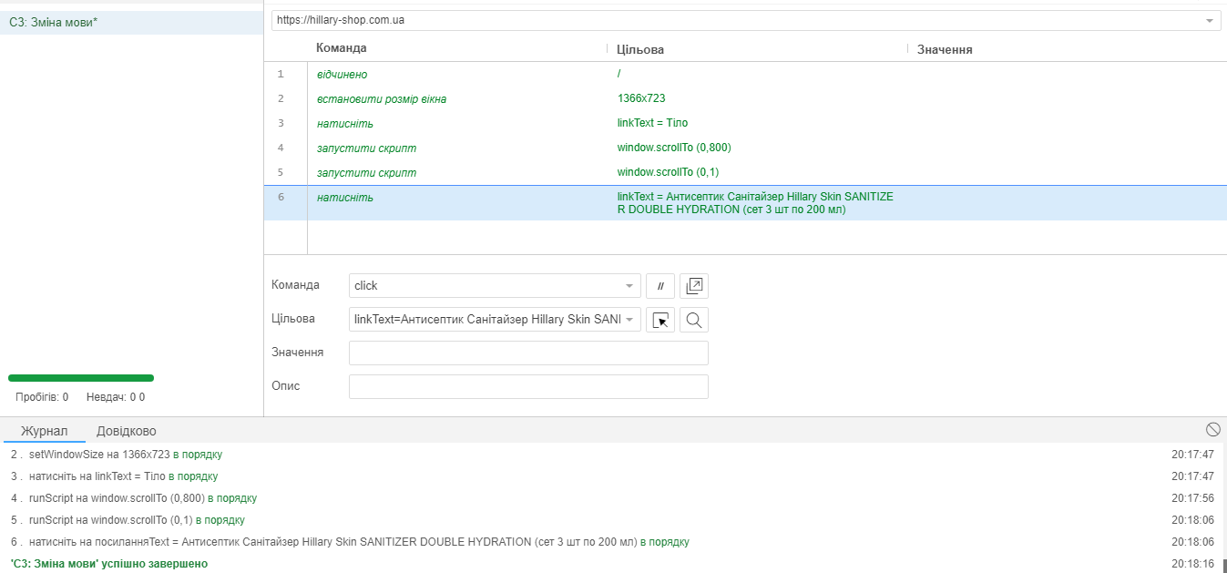

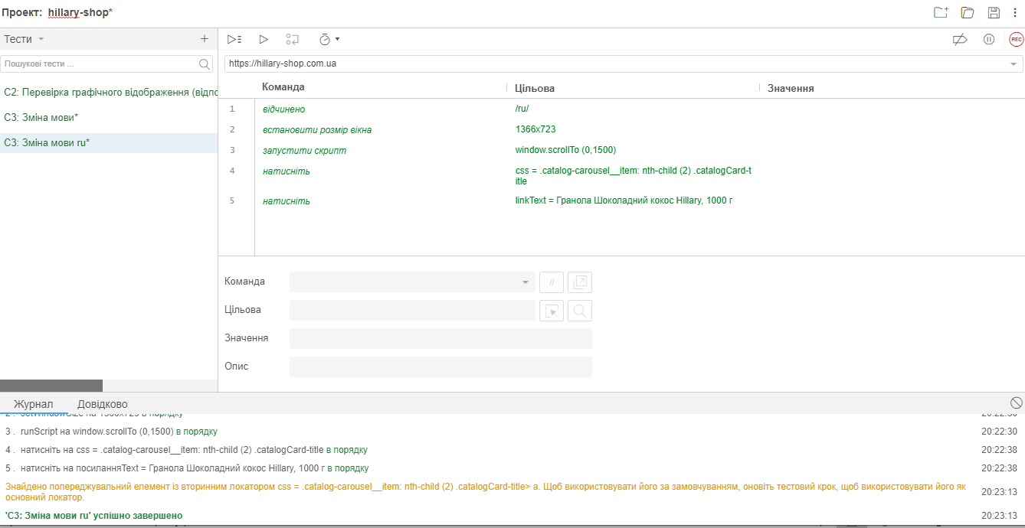

1. С5: Creating an account

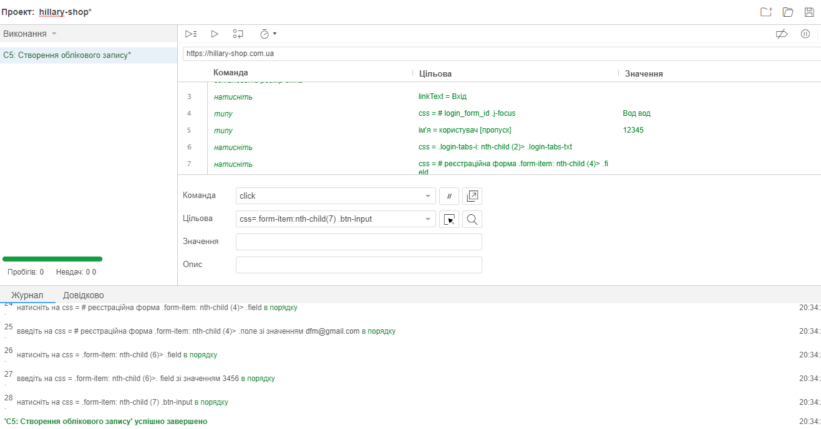

1. С6: Functional " Add products to the basket "

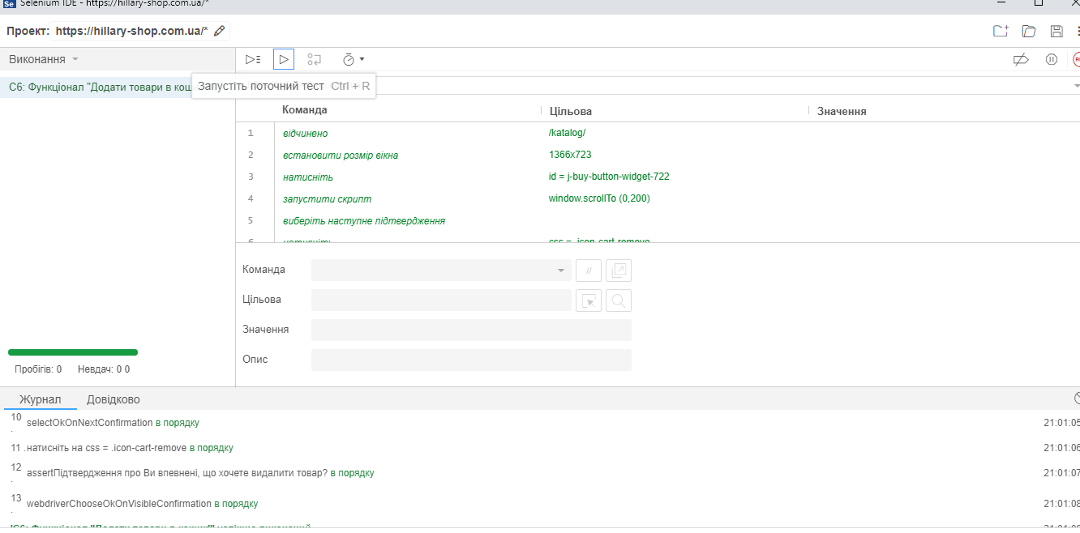

1. С7: Functional «Filters», using of two filters at the same time

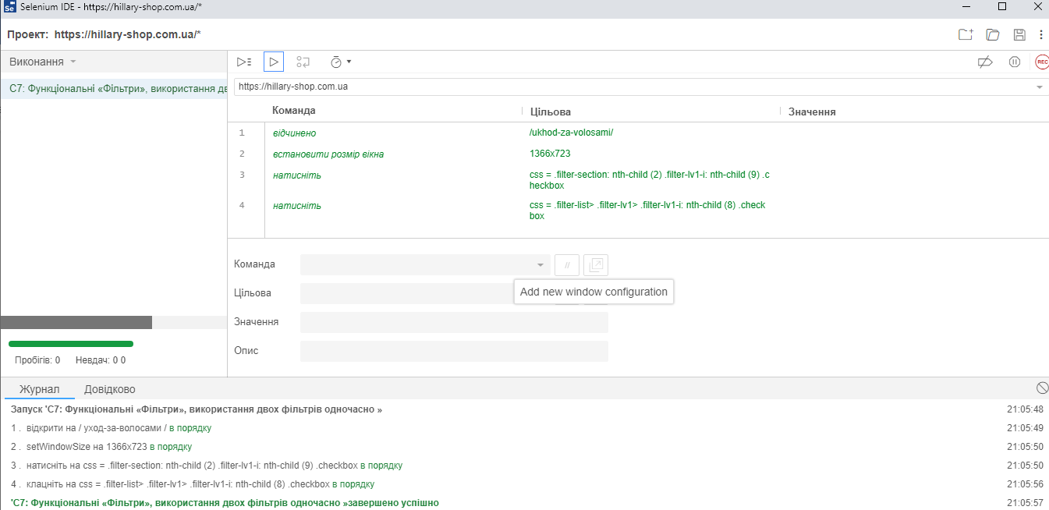

1. С9: Functional " Sorting "

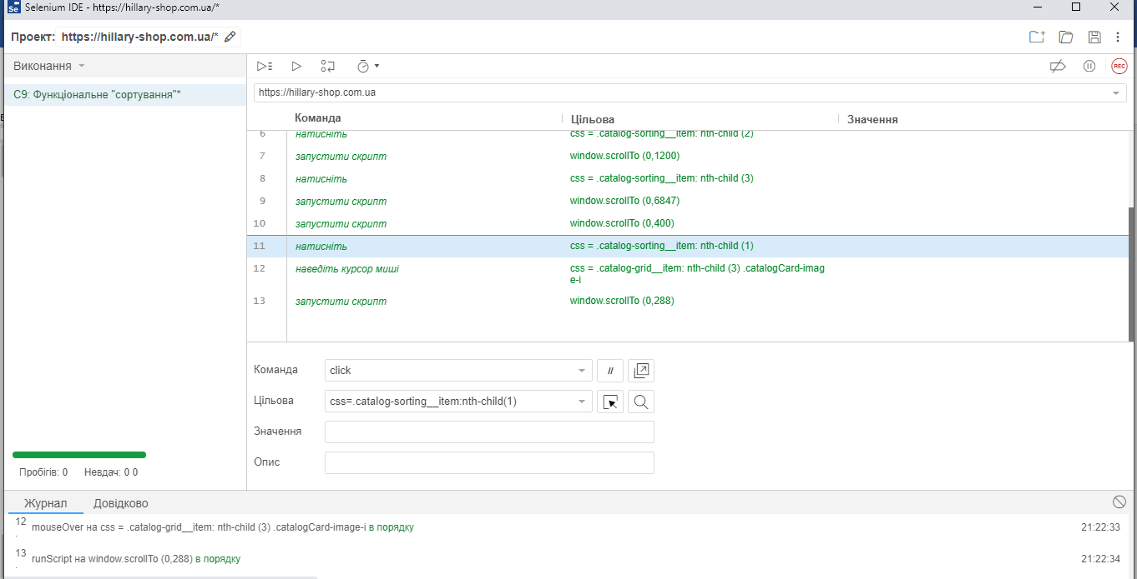

1. С11: Using all filters and sortings

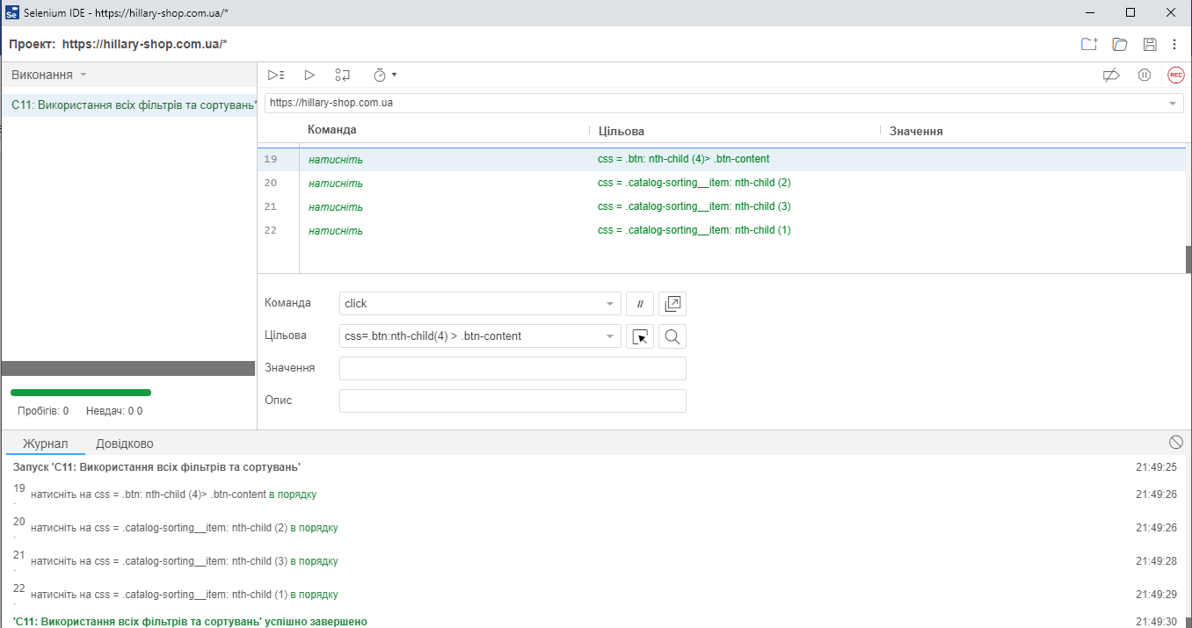

1. С12: "Add products to the basket "

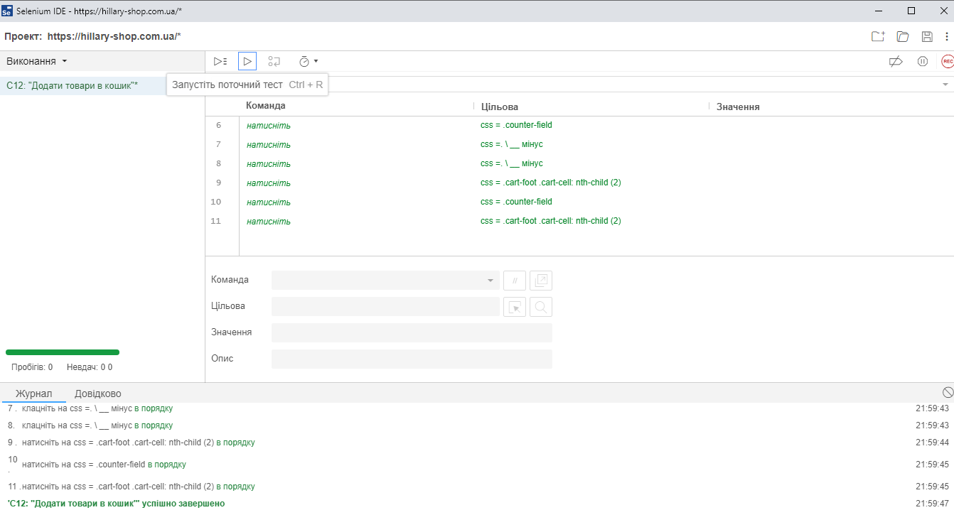

1. **С14: " Ordering product which is not available"**

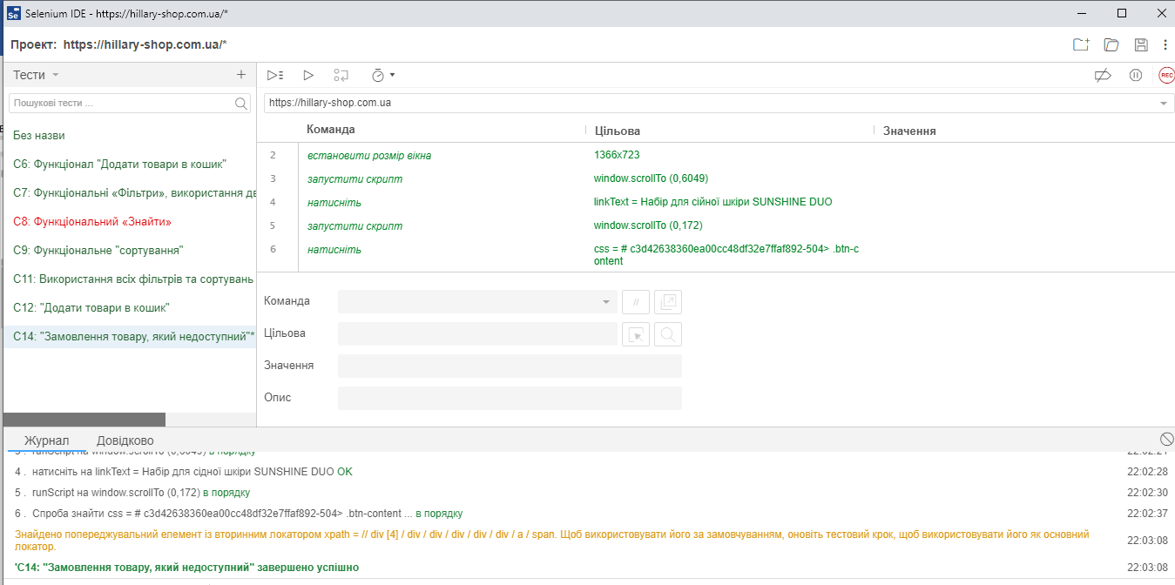

1. **С15: Functional "Замовлення через кошик: 24/7/365 днів"**

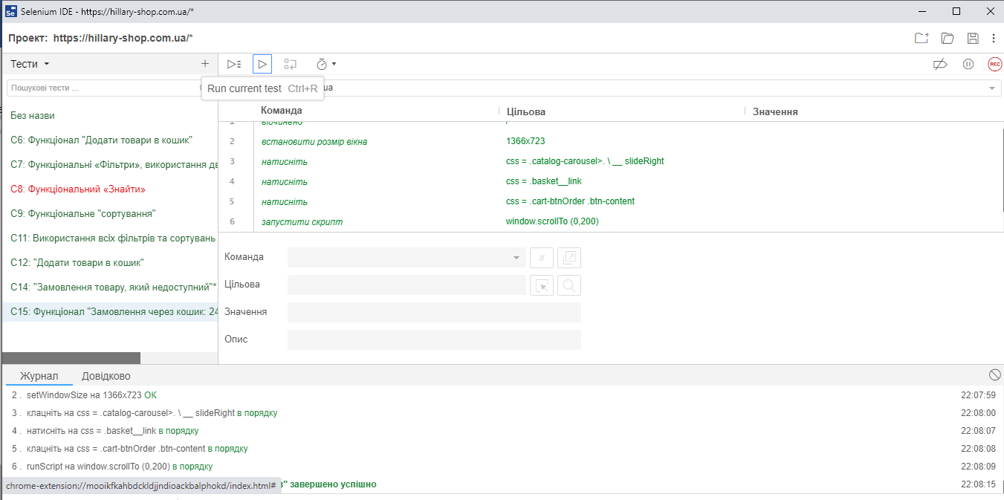

# **Write 10 user stories to the functionality of the site, turn them into requirements**

|  |  |
| --- | --- |
| № | User story |
| 1 | As a user of the site, I want to have a personal account for the convenience of ordering |
| 2 | As a user of the site, I want all the data on the page to be Ukrainian, as I am Ukrainian |
| 3 | As a user of the site, I want the language on the page to be changed to Russian, because although I am Ukrainian, I speak Russian. |
| 4 | As a user of the site, I want the products to be comparable, as you often do not know which one is better |
| 5 | As a potential customer, I want the products to be added to the cart, as I never order a single product, I save on shipping |
| 6 | As a potential customer of the goods, I want that to increase quantity of the goods in a basket, not to add the goods to a basket 15 times on 1 piece |
| 7 | As a user of the site, I want to log in to my personal account via Google account, so as not to enter the phone number every time and wait for a message from the operator |
| 8 | As a user of the site, I want to log in to my personal account via Facebook, so as not to enter the phone number every time and wait for a message from the operator |
| 9 | As a potential customer of the product, I want to put different filters on the product to make it easier to choose a product that suits me by all criteria |
| 10 | As a potential customer of a product, I want the product to be added to the cart only if it is available, so as not to order a product that is not available and then not wait for a refund, or until the product appears in stock |
| № | Requirement |
| 1 | Personal account for users, logging in by phone number, right at the top of the main page |
| 2 | Site localization in Ukrainian |
| 3 | Site localization in Russian |
| 4 | Product comparison function |
| 5 | The function of adding goods to the cart |
| 6 | Adding goods to the cart in a certain quantity, the ability to adjust the quantity of the ordered goods |
| 7 | Logging in of users in the personal account via Google account |
| 8 | Login of users in a personal account via Facebook |
| 9 | Function of putting filters "Credit 0,01%", "Payment in installments%", "Promotions", "Discounts", "Gifts", "Pre-order", and also putting of several filters at the same time |
| 10 | Adding an item to the cart only if it is available |

# **Write 10 user stories to the external interface of the site, turn into requirements**

|  |  |
| --- | --- |
| № | User story |
| 1 | As a user of the site, I want the site to be able to shrink and enlarge and the size of the pictures of goods to change according to the scale, because I have poor eyesight, and my mother -6. |
| 2 | As a site user, I want the site to be able to use the site from different devices, such as a tablet, because I don't have a laptop |
| 3 | As a site user, I want the site to be able to use the site from different devices, such as a phone, because I don't have a laptop |
| 4 | As a user of the site, I want the color of the site to be white, so that the bright colors of the site do not interfere with viewing the product |
| 5 | As a potential customer, I want all products to be grouped into categories: body, hair, face, natural oils, expert complexes, health food |
| 6 | As a site user, I want the site's favicon to be H |
| 7 | As a user of the site, I want the contact information to be placed on each page of the site in the upper right corner so that it is visible |
| 8 | As a potential customer, I want to have a stock button, as I love to save money and buy everything on stock. |
| 9 | As a potential customer of the product, I want the bottom of the site to display the products I viewed, so as not to waste time searching for the product again. |
| 10 | As a potential customer of the product, I want it to be possible to leave a review about the product, because when choosing a product I would like to know whether the people who bought this product are satisfied |
| № | Requirement |
| 1 | Increase and decrease the size of the site, the size of images of goods change according to scale |
| 2 | Using the site from the tablet, adapting the site to the size of the tablet (all product images and font must change to the size of the tablet screen) |
| 3 | Using the site from the phone, adapting the site to the size of the phone (all product images and font must change to the size of the phone screen) |
| 4 | White color of the site |
| 5 | All products are grouped into categories: body, hair, face, natural oils, expert complexes, health food |
| 6 | The site's favicon " H " |
| 7 | The contact information is placed on each page of the site in the upper right corner of the site |
| 8 | Create a "Promotions" button in a prominent place (top of the page in the left corner) |
| 9 | In the bottom of the site displayed the products which were viewed |
| 10 | A possibility to leave a review about the product |

# **All defects which were found on the site write in the bug reports, set the type, priority, severity**

**ID – 1**

**Summary** Registration with invalid E-mail fgh@gmail.com on the website https://hillary-shop.com.ua/

**Type** Functional

**Pre-conditions**

1. Go to the main page of the site https://hillary-shop.com.ua/

2. Press the personal account button.

3. Click the Login button.

**Steps**

1. Сlick the button "Log in to personal account"

2. Enter «asdfghj» in the name field

3. In the field E-mail «fgh@gmail.com»

**Post-conditions**

**Severity** 4

**Priority** 4

**Screenshot**

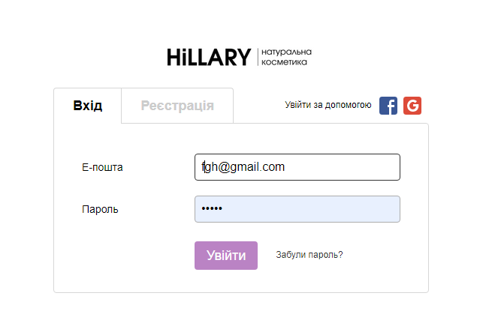

**Actual result** Ability to register with an invalid Email.

**Expected result** Ability to register with a valid Email, sending a confirmation code to Email

**ID – 2**

**Summary** Registration with low security password on the website https://hillary-shop.com.ua/

**Type** Functional/Security

**Pre-conditions**

1. Go to the main page of the site https://hillary-shop.com.ua/

2. Press the personal account button.

3. Click the Login button.

**Steps**

1. Сlick the button "Log in to personal account"

2. Enter «sdfghj» in the name field

3. In the field E-mail «erty@gmail.com»

4. Enter «12345» in the password field

**Post-conditions**

**Severity** 4

**Priority** 4

**Screenshot**

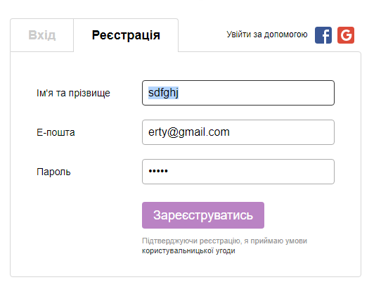

**Actual result** Ability to register with low

**Expected result** Ability to register with an average or high level of password security.

For example: Assdfg1234@

**ID – 3**

**Summary** During switching language from Russian to Ukrainian in the section “Тіло” there is an error in the translation of word in the product description «Набір для ідеальної шкіри тіла в домашніх умовах "Nice body Plus"»

**Type** Localization

**Pre-conditions**

1. Open site https://hillary-shop.com.ua/

2. The language of the site is switched from Russian to Ukrainian

**Steps**

1. Go to the section of goods «Тіло»

2. Go to product section «Засоби для епіляції Hillary Epilage»

3. Find the product “Набір для ідеальної шкіри тіла в домашніх умовах "Nice body Plus"

4. Open the product description.

**Post-conditions**

**Severity** 2

**Priority** 2

**Screenshot**

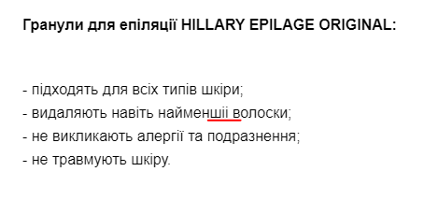

**Actual result** In the product description, the word “найменшіі” is incorrectly translated into Ukrainian.

**Expected result** During changing the language from Russian to Ukrainian, all words are correctly translated into Ukrainian.

**ID – 4**

**Summary** Visual check of grammar and the presence of spaces and symbols in sentences.

**Type** Usability

**Pre-conditions**

1. Open site https://hillary-shop.com.ua/

2. The language of the site is switched from Russian to Ukrainian

**Steps**

1. Go to the section of goods «Тіло»

2. Go to product section «Засоби для епіляції Hillary Epilage»

3. Find the product “Набір для ідеальної шкіри тіла в домашніх умовах "Nice body Plus"

4. Open the product description.

**Post-conditions**

**Severity** 2

**Priority** 2

Screenshot

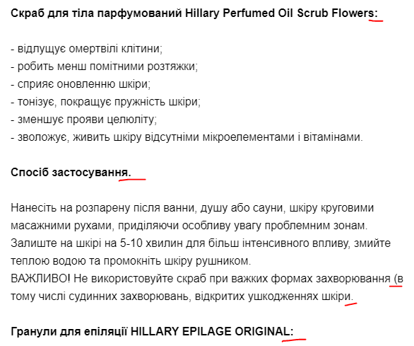

**Actual result** In the description of the product different symbols, in one sentence ":" before the description, and in another "." The parenthesis is also missed.

**Expected result** No extra spaces or characters in the text.

**ID – 5**

**Summary** Making an order with invalid credits (name, city, address) on the website https://hillary-shop.com.ua/

**Type** Functional

**Pre-conditions**

1. Go to the main page of the site https://hillary-shop.com.ua/

2. Press the personal account button.

3. Click the Login button.

**Steps**

1. Сlick the button "Log in to personal account"

2. Enter «цукенг» in the name field

3. In the field E-mail « [dsfghjkl@gmail.com»](mailto:dsfghjkl@gmail.com)

4. Enter «ц3укенгшщ » in the address field

**Post-conditions**

**Severity** 4

**Priority** 4

**Screenshot**

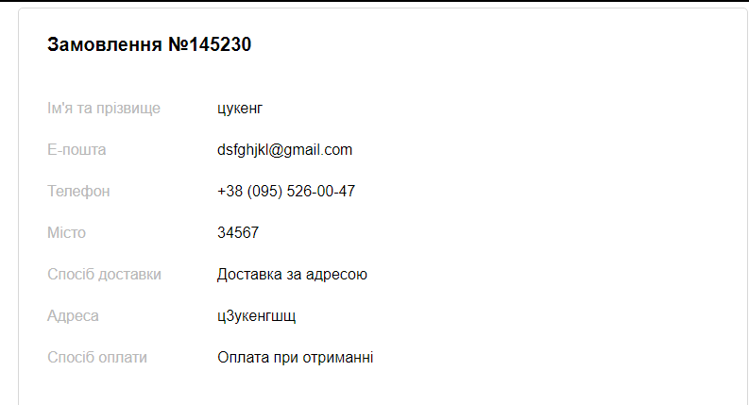

**Actual result** Ability to make an order with an invalid personal data.

**Expected result** Ability to make an order with a valid personal data, E-mail, address.

# **Create a database that could match the site (users, products for the online store, etc.). An average of 3 tables (at least 10 units in the table). Create the necessary links in the table, fill the tables with data.**

